Describing the 'triple burden' of dissavings, catastrophe and disruption of social life among TB patients on treatment in Kenya

Peter Nguhiu1, Jacquie Oliwa1, Eunice Mailu2, William Rudgard3

*1KEMRI Wellcome Trust Research Program; 2Ministry of Health, National TB Leprosy and Lung Disease Program; 3London School of Hygiene and Tropical Medicine, Department of Infectious Disease Epidemiology.*

Background: Kenya has committed to provide universal health coverage for her population. Kenya has a mixed service delivery system for health, with only approximately half of all health facilities being public. This necessitates complex health system and financing arrangements to ensure TB care services are available to all. The recent Kenya TB Prevalence survey revealed a prevalence of 588 (455 – 662) adults per 100,000, while program data reveals numerous gaps in case notification, treatment and retention especially among pediatric TB cases. Using the First Kenya TB patient cost survey data, this study describes the triple burden of catastrophic expenditure, dissavings and disruption of social life (including loss of sources of livelihood and experiencing social exclusion as a result of TB treatment) among households with TB patients.

Methods: Data was obtained from a two-stage cluster sampled patient survey conducted between May and June 2017, which reached 1071 drug sensitive (DS) and 282 drug resistant (DR) patients. Patients and caregivers were asked about the costs incurred and their experiences while obtaining TB services, plus the social consequences experienced due to taking TB treatment. The computation of catastrophic expenditure was based on the proportion of households with total costs above a threshold of 20% of annual household expenditure.

Findings: 14.2% (CI 8.6, 22.6) of DR patients and 5.8% (CI 4.5, 7.6) of DS patients experienced the triple burden of catastrophic expenses, dissavings and disruption of social life. From survey adjusted multivariate logistic regression, the odds of experiencing the triple burden increased 3.6 (CI 1.5, 8.5) times for households with paediatric patients compared to households with adult TB patients and increased 2.5 (1.0, 6.3) times for DR TB patients. Households in the lowest expenditure quintile and those with lower levels of education were also more likely to experience the triple burden. There was no significant difference in odds across male and female patients, nor across public or private facilities accessed for treatment.

Discussion: Despite the immense subsidies to TB treatment across public and private facilities, the poorest and least educated households remain vulnerable to socioeconomic shocks while accessing TB services. Households with DR-TB patients and paediatric TB patients are similarly more likely to face catastrophic expenses, dissavings and disruption of social life perhaps due to their specific diagnosis and treatment pathways that are prolonged and complex. National TB programs need to explore mechanisms for deepening social protection for vulnerable households undergoing TB treatment.

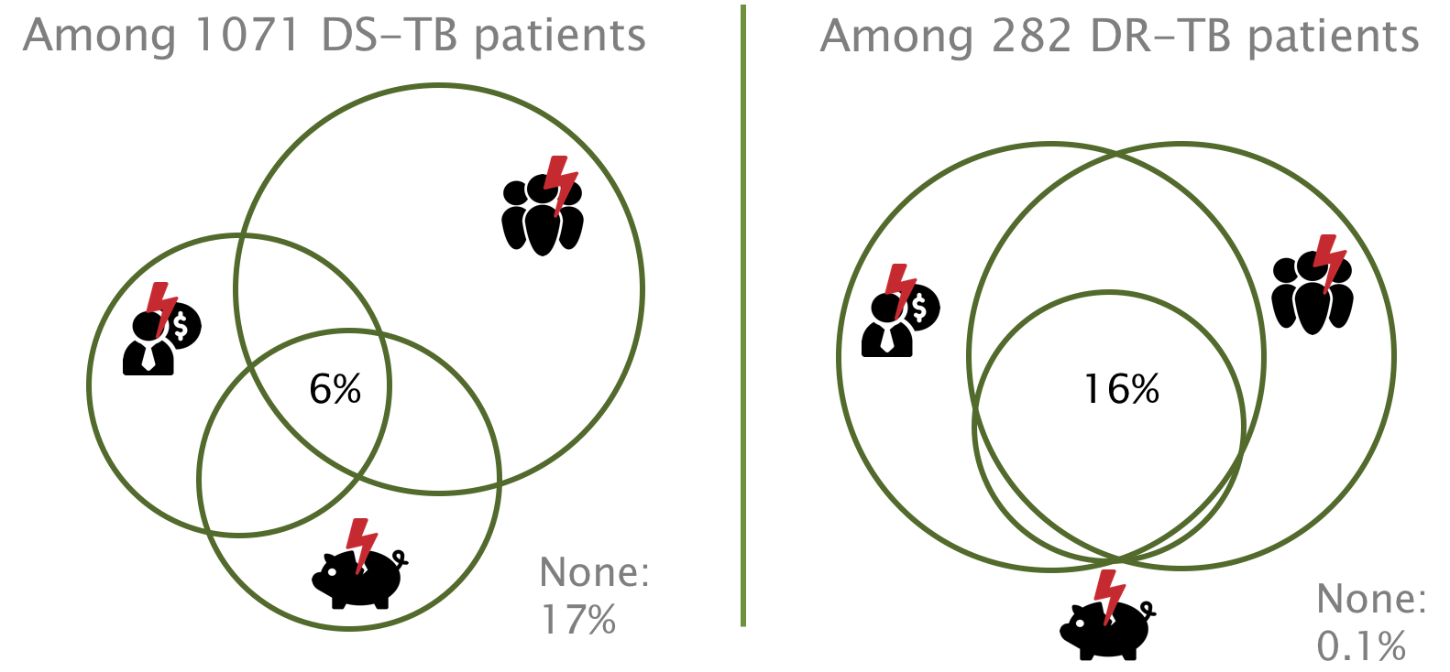

Figure 1: Incidence of ‘triple burden’ among TB patients on care in Kenya, 2017