**Title**

Building capacity of the South African Department of Health to undertake HIV expenditure tracking and value for money analysis – a collaboration between research and capacity building institutions and donors

**Authors**

Teresa Guthrie, Nhlanhla Ndlovu, Kavya Ghai, Michael Chaitkin, Nthabiseng Khoza, Nomkhosi Mathenjwa, Vincent Madisha, Silindile Shezi, Joshua Karume, Portia Motsoeneng, Siphethelo Simelane, Gesine Meyer-Rath, Sithabiso Masuku, Lise Jamieson.

Presenter: Teresa Guthrie, [guthriehealthfinancingconsult@gmail.com](mailto:guthriehealthfinancingconsult@gmail.com), South Africa

**Background**

The South African government’s increasing allocation of resources for HIV requires substantial financial planning with development partners. To assess past allocative efficiency and improve joint planning, the National Department of Health collaborated with USAID’s Health Financing and Governance and FIN-CAP projects to assess past spending on HIV and TB, as well as to build capacity within the NDOH and automate the analysis of the public accounting system.

**Methods**

We analysed HIV and TB spending in South Africa by the government, PEPFAR and the Global Fund by cross-walking and consolidating into a single database information from the public accounting system and donor datasets. We built on earlier exercises to develop time trend datasets and to strengthen the capacity of NDOH to undertake this analysis routinely, with the assistance of an automated data extraction tool.

**Results**

HIV and TB spending from South Africa’s main financing sources increased from ZAR 22.5 billion in 2014/15 to ZAR 28.8 billion in 2016/17. The government contributed the largest share in 2016/17 (76%, down from 80% in 2013/14), followed by PEPFAR (22%, up from 19% in 2015/16) and the Global Fund (3%, down from 6% in 2015/16). Of total spending in 2016/17, 87.5% went to HIV interventions, 8.4% to TB, and the remaining 4.1% to TB/HIV integrated activities. While government funds 83% of ART costs, donors contribute substantially to prevention, programme enablers, and care and support (Figure 1 below).

**Conclusion**

These data provide valuable evidence for the resource allocation decision-making process and can inform better alignment of all partner efforts to the National Strategic Plan priorities. They also highlight which elements of South Africa’s HIV response are most vulnerable to diminishing donor funding. The collaboration between the government, R4D, HE2RO and CEGAA (FINCAP) with USAID funding was innovative and enabled the skills transfer for sustainability and routinized expenditure tracking that directly informed national allocative choices and provincial programmatic financial management.

Figure 1. Funders' relative contributions to HIV programme areas (totals in Rand, FY 2016/17)

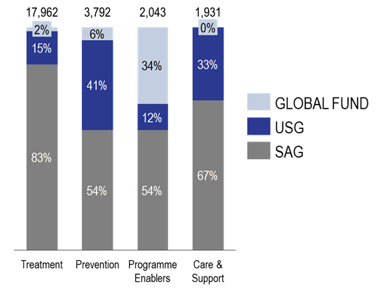

**Author information**

|  |  |
| --- | --- |
| Teresa Guthrie | Results for Development Institute, South Africa |
| Michael Chaitkin | Results for Development Institute and American University School of International Studies, USA |
| Nthabiseng Khoza | National Department of Health, South Africa |
| Nomkhosi Mathenjwa | National Department of Health, South Africa |
| Vincent Madisha | National Department of Health, South Africa |
| Nhlanhla Ndlovu | Center for Economic Governance and Accountability in Africa, South Africa |
| Silindile Shezi | Center for Economic Governance and Accountability in Africa, South Africa |
| Joshua Karume | Center for Economic Governance and Accountability in Africa, South Africa |
| Portia Motsoeneng | Center for Economic Governance and Accountability in Africa, South Africa |
| Siphethelo Simelane | Center for Economic Governance and Accountability in Africa, South Africa |
| Gesine Meyer-Rath | Health Economics and Epidemiology Research Office, South Africa |
| Sithabiso Masuku | Health Economics and Epidemiology Research Office, South Africa |
| Lise Jamieson | Health Economics and Epidemiology Research Office, South Africa |
| Kavya Ghai | Results for Development Institute, Ethiopia |